**Monetizing To Do List App with Sumup mPOST SDK**

The SumUp mPost SDK is very useful for Merchants and Business for monetizing there applications and make the payment process easy and secure for customers.

The proposed Minimal TO-DO is having dependencies conflict when integrating with sumUp mPost SDK dependency. Therefore ,I have a taken a very simple ToDo List APP.

Link: <https://github.com/farsabbutt/Todo/tree/master/app>

The app is very simple demonstration of ToDo list. I have monetized this app .

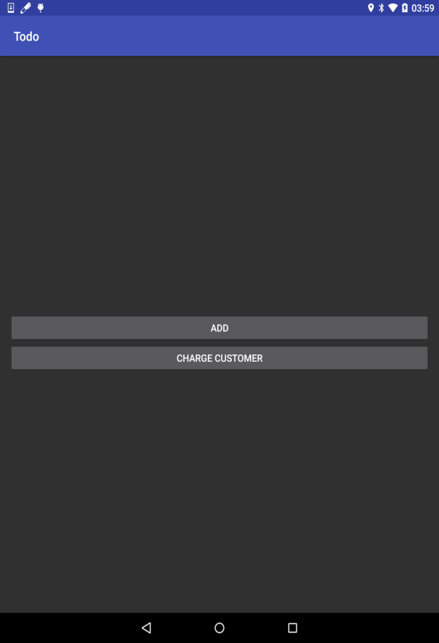 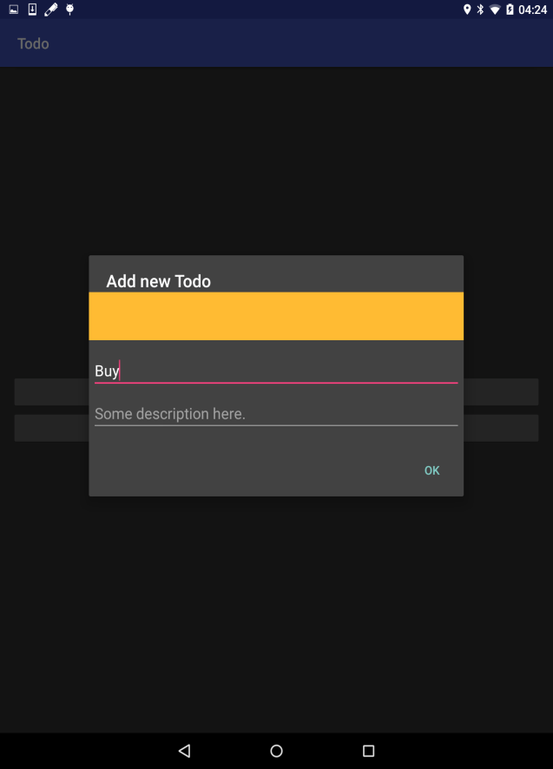

The first right screeshorts above shows the first screen of the TODO app.The secound one shows the screen that comes when clicked on “ADD Button”.

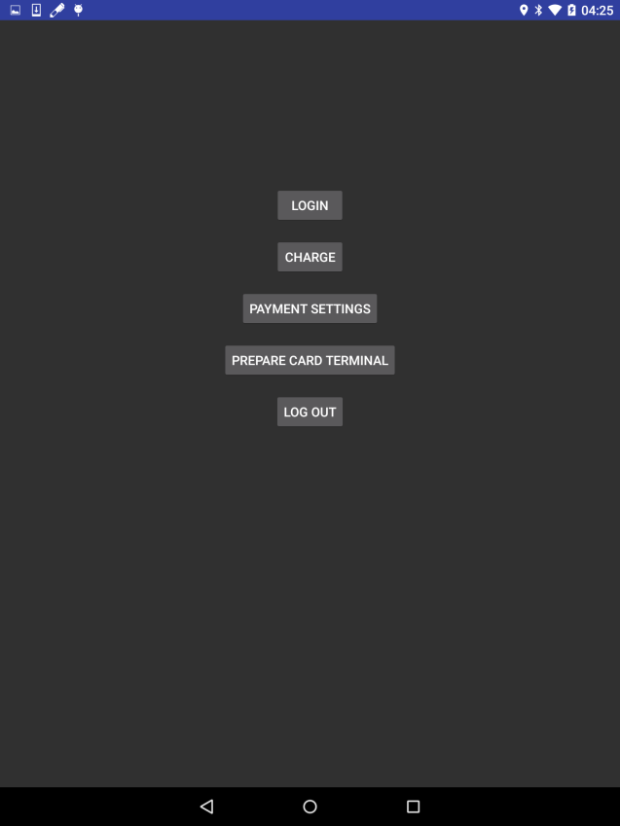 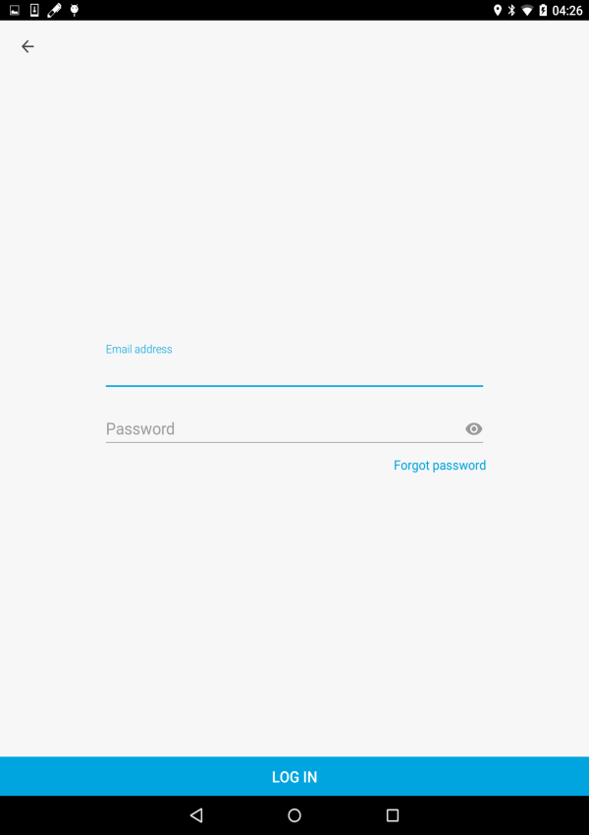

The above two screen appears when clicked on the “Charge Customer” button is clicked and the SumUp login is required for intonating the payment process for the customer.

After this the screen shows us option for payment. And After a successful payment the payment receipt is given send on customer’s mobile and a copy of that receipt that is accessed through the SumUp REST API is shown on the merchant’s application. As shown in the below screenshot. I have used okHttp for getting response from the API.

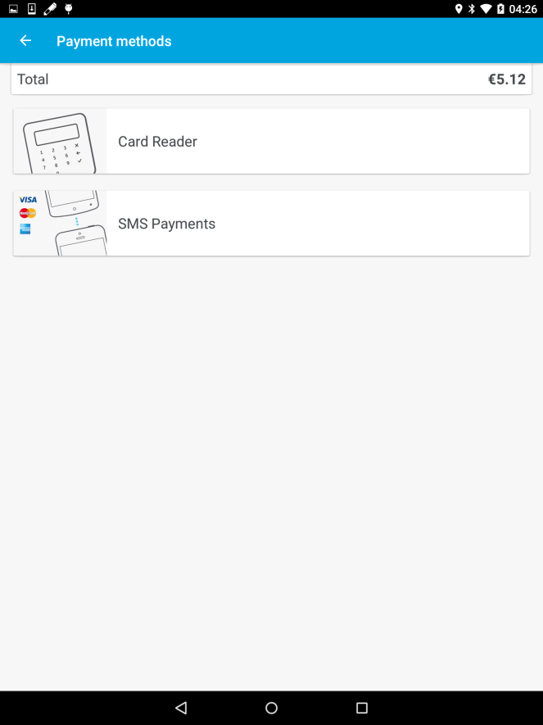 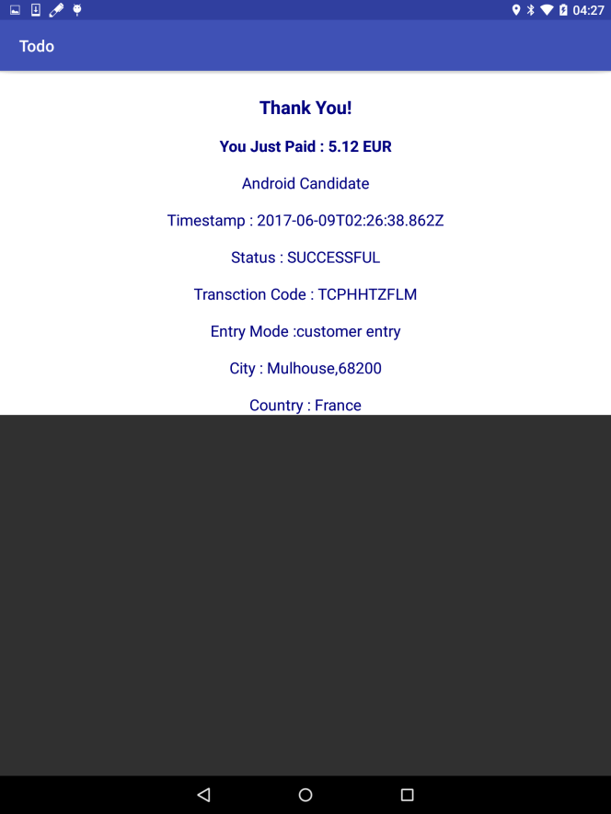

While trying to resolve errors in Minimal APP and accessing the SumUP Rest API , it caused me a lot time.

If I had more time I would add the rest api for getting information about all the transaction done by a client ,improve the GUI of the app with location shown on Google Maps inside the app and writing test for the app.